For Immediate Release
Contact: Mike Ruzicka
414.778.4929 or 414.870.1874
mike@gmar.com
May 12, 2025

April Home Sales Down 5.3%

Highlights
- Sales Down But In Line With Recent Years
- Listings Down Slightly But Up for the Year
- Average Sale Price Up 11.7%

April Sales
County | 2024 | 2025 | % Change
Milwaukee | 881 | 780 | -11.5%
Waukesha | 358 | 376 | 5.0%
Ozaukee | 80 | 92 | 15.0%
Washington | 143 | 136 | -4.9%
Metro Area | 1,462 | 1,384 | -5.3%
Racine | 162 | 207 | 27.8%
Kenosha | 140 | 125 | -10.7%
Walworth | 96 | 136 | 41.7%
SE WI Area | 1,860 | 1,852 | -0.4%
April Listings
County | 2024 | 2025 | % Change
Milwaukee | 1115 | 1073 | -3.8%
Waukesha | 535 | 600 | 12.1%
Ozaukee | 136 | 123 | -9.6%
Washington | 172 | 155 | -9.9%
Metro Area | 1,958 | 1,951 | -0.4%
Racine | 245 | 284 | 15.9%
Kenosha | 197 | 202 | 2.5%
Walworth | 144 | 180 | 25.0%
SE WI Area | 2,544 | 2,617 | 2.9%
Market Summary
The Metropolitan Milwaukee housing market was down 5.3% in April, with 78 fewer sales than a year earlier.

While April was the third month in a row that sales decreased compared to 2024, year-to-date sales total 4,396, only 101 units behind 2024. Comparing the year-to-date totals for 2023 and 2025 shows the market 314 units ahead this year.

The market saw a significant change in June 2022 when mortgage interest rates spiked. Annual sales dropped from over 20,000 units in 2022 to 16,586 in 2023 and 17,058 in 2024.

Thus far in 2025 the market appears to be performing similarly to the last two years, a little behind 2024 but ahead of 2023.

The 2022 increase in interest rates pushed some buyers out of the market, but, more importantly, it pulled more listings out of circulation. The decrease in sales is more related to fewer properties available to buy than too few buyers.

In fact, the period from just before interest rates increased in 2022 to the fall of 2023 was one of the most anemic periods for listings the market has seen this century.

Unfortunately, the new homes side of the ledger has also been unable to meet demand for years. The market could use more than 4,000 additional units for buyers to choose from.

There are still many motivated buyers seeking to purchase a home. Brokers are reporting multiple offers for appropriately priced houses all over the metropolitan area. Properties in the $200,000 - $399,999 price range accounted for over 45% of the April market. That is the sweet spot for Millennial and Generation Z first-time home buyers, as well as empty nesters looking to downsize.

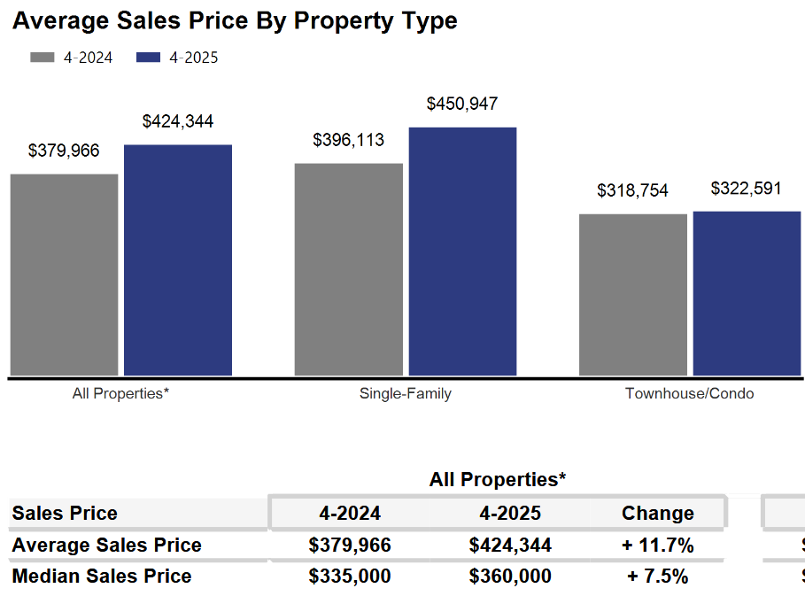
As economics dictates, when there is high demand for a product and low supply, the cost goes up. And due to the current levels of demand and supply, the average home sale price in the four-county area went up 11.7% in April, from $379,966 in 2024 to $424,344 in April 2025.


That demand is created by buyers who want all the quality-of-life benefits that homeownership offers, so they are stretching to qualify for a loan, or come up with enough cash to get a house.

As we have been highlighting for several years – REALTORS® have had an exceedingly challenging time helping home buyers find ownership opportunities in the form of condos and single-family houses. This results in thousands of would-be homeowners forced to stay in rental units, unable to save for a down payment and foregoing the opportunity to build wealth through a home’s equity.

Where to go
Buyers should seek the counsel of a REALTOR® in determining their best housing options, and sellers need the expert advice of a REALTOR® in making correct marketing decisions for their home.

The Greater Milwaukee Association of REALTORS® is a 5,500-member strong professional organization dedicated to providing information, services, and products to help REALTORS® help their clients buy and sell real estate. Data for this report was collected by Metro MLS, Inc., a wholly owned subsidiary of GMAR.

* Sales and Listing figures differ between the “Monthly Stats” and quarter or year-end numbers, because the collection of Monthly Stats ends on the 10th of each month, whereas quarters are a continuous tally to 12/31. For example, if a sale occurred on the 29th of the month, but an agent does not record the sale until the 5th of the next month, that sale would not be included in the sales figures of the reported month (or any subsequent month’s total) but would be added to the quarterly and annual total sales figures.

** All references to the “metropolitan” area denotes the four counties of Milwaukee, Waukesha, Ozaukee, and Washington Counties. The “region” or “Southeast Wisconsin” refers to the four metropolitan counties (Milwaukee, Waukesha, Ozaukee, and Washington), plus Racine, Kenosha, and Walworth Counties, to the south.

Seasonally adjusted inventory tells us how many months it would take to sell the existing homes on the market. The seasonally adjusted inventory level for April was 2.7 months. Subtracting 1,737 “active offer” listings from those available for sale (about 80% of listings with an offer sell) yields 3,193 listings, which equals 1.0 months of inventory.

With 3,749 current listings providing 2.7 months of inventory, the market would need an additional 4,6355 units to push inventory to six months. Six months of inventory is considered a “balanced” market. If inventory falls below six months, the market favors sellers, and when inventory exceeds six months, it is a buyer’s market.

